Ideation Phase
Brainstorm & Idea Prioritization Template
Date | 10 July 2026
Team ID | [Your Team ID]
Project Name | House Rent — Broker-Mediated Real Estate Platform
Maximum Marks | 4 Marks
Brainstorm & Idea Prioritization:
The team held a brainstorming session around the core problem: renters and buyers can't trust listings on informal channels, and owners have no way to screen who they're dealing with. The session below captures the ideas raised, how they were grouped, and how we prioritized them.
Step 1: Team Gathering & Problem Statement Selection
The team agreed the central problem statement to solve for was: “Renters and buyers cannot verify the authenticity of a property listing or the identity of an owner before engaging with them, and owners/admins have no shared workflow to moderate listings.”
Step 2: Idea Listing & Grouping
Ideas raised during the session were grouped into four themes:
- Trust & Moderation — admin approval workflow, owner verification/“granted” status, one review per completed booking only
- Discovery & Search — filter by location, price range, property type, and rent vs. sale
- Account Model — a single login usable as both Owner and Renter, admin accounts never self-registrable
- Delight Features — map view, PDF receipts, dark/light mode, chat, real-time notifications
Step 3: Idea Prioritization
Each idea was plotted on an Impact vs. Effort matrix to decide what to build first. Ideas in the top-left (high impact, low effort) were treated as must-haves for the first release; ideas in the bottom-right were logged as stretch goals for later phases.
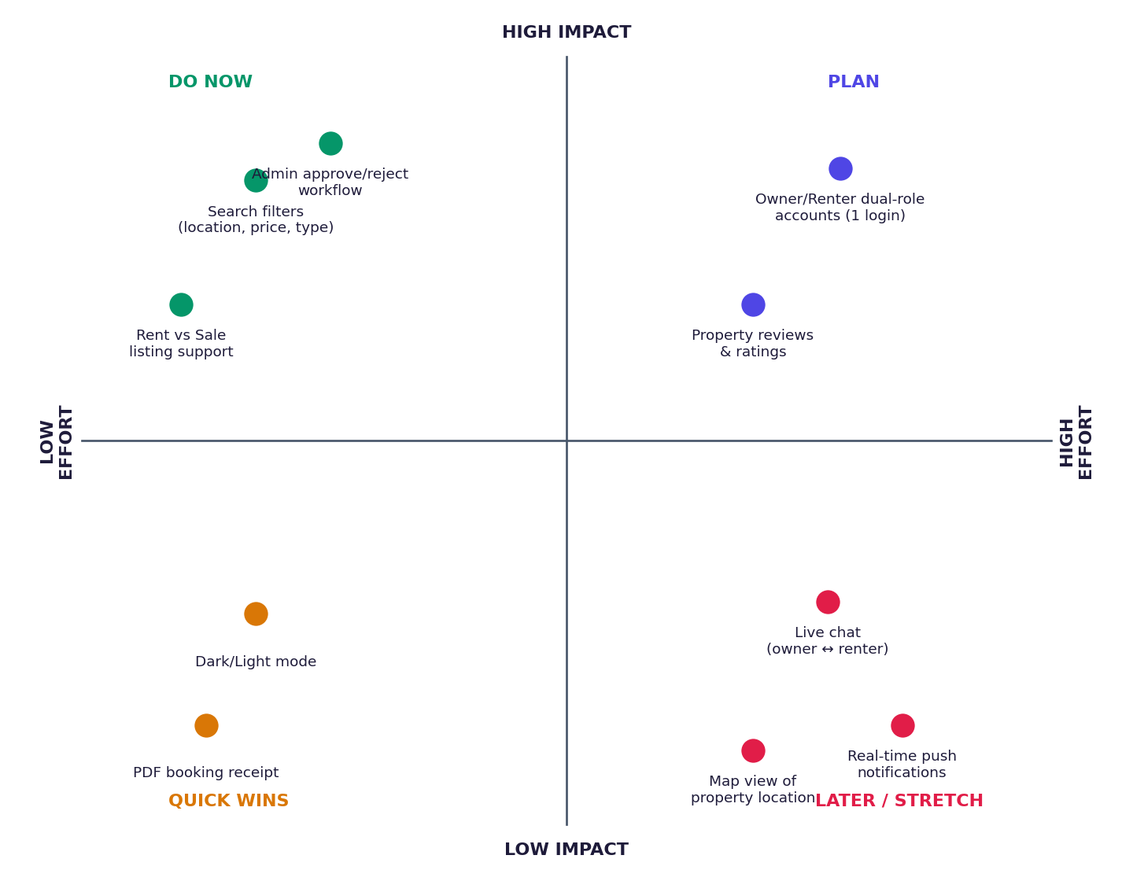
Figure: Impact vs. Effort prioritization for House Rent features
Outcome: the broker-style approval workflow, rent/sale support, and search filters were built first as the core “Do Now” items. Dual-role accounts were treated as a high-value “Plan” item and built next. Chat, live notifications, and map view were parked as later-phase enhancements since they need real-time infrastructure that isn't essential to the core marketplace loop.

